Technical characteristics of the purchased goods:
1)DJI Terra Standard Permanent software is a license for permanent (without expiration date) use of the standard version of DJI Tera.
DJI Terra is a software from DJI manufacturer designed for flight planning, collection, processing and analysis of aerial photographs, 3D maps and other geodata.
Main features and functions in the Standard version
The standard edition includes the following features (depending on the compatible drone/payload):
Flight planning (survey plans) — based on coordinates, routes, and tasks for aerial photography.
Shooting control: Launch missions, collect images/dots, control camera/payload.
Processing of the received data: the formation of orthophotocards, 3D models (monohull clouds, 3D point clouds / meshes), digital terrain models (DEM), digital surfaces (DSM) and orthoimages.
Geolocation (georeference) of data, export of results to common formats for GIS / cartography / CAD / GIS software, which makes it possible to further work with models in other systems.
Support for receiving data from various payloads (cameras, LiDAR, multispectral modules, etc.), depending on compatibility with the drone.
The ability to process medium–volume projects - for cartography, inspections, 3D modeling of sites, buildings, territories, landscapes.

2) Inflatable Boat REEF 420 ND JET light grey/turquoise
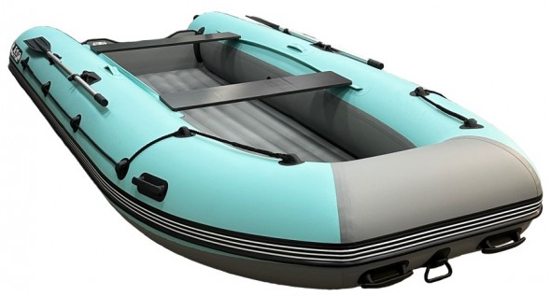
2 cans (seats).
2 paddles (160 cm).
Foot pump.
Repair kit.
Passport and bag.
The REEF brand.
Kit weight: 57 kg.
Load capacity: 900 kg.
Side diameter: 500 mm.
Boat length: 4200 mm.
Number of compartments: 3+bottom.
Material: PVC.
Passenger capacity: 6 people.
Side fabric density: 1100 g/m2
The density of the inflatable bottom fabric is 1100 g/m2.
Cockpit dimensions length/ width: 2780/830 mm.
Country of manufacture: Russia.
Bottom type: JET tunnel.
Boat type: Motor rowing boats.
Boat width: 1840 mm.

3) DJI TB100 Intelligent Flight Battery - for DJI Matrice 400
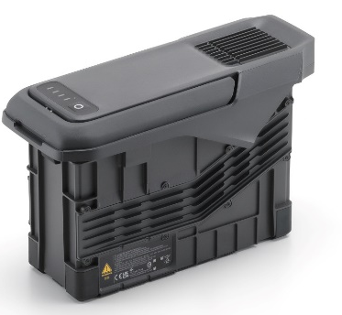
Capacity: 20254 mAh
Standard voltage: 48.23 V
Battery Type: Lithium-ion
Energy: 977 WH
Weight: 4720 ± 20 g
Compatibility: DJI Matrice 400

4) Aircraft (quadcopter) DJI Matrice 400
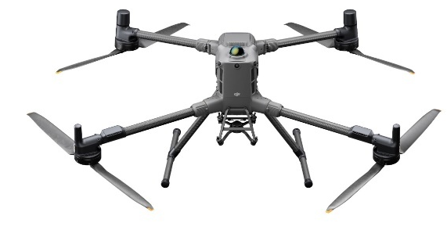
• Take-off weight (with propellers): Without batteries: 5020±20 g. With batteries: 9740±40 g. The actual weight of the product may vary due to differences in batch materials and external factors.
• Maximum take-off weight: 15.8 kg
• Dimensions: Unfolded: 980×760×480 mm (L×W×H) (with chassis). Folded: 490×490×480 mm (L×W×D) (with chassis and gimbal). Maximum dimensions excluding propellers. Dimensions of the drone transport case: 779×363×528 mm (L×W×D).
• Maximum payload: 6 kg. The load capacity of 6 kg is measured at the third connector at sea level. The load capacity decreases with increasing altitude above sea level. For more information, see the official user's guide.
• Propeller size: 25 inches.
• Diagonal wheelbase: 1070 mm.
• Max. Lifting speed: 10 m/s.
• Max. Rate of descent: 8 m/s.
• Max. horizontal speed (at sea level, without wind): 25 m/s.
• Max. takeoff height: 7000 m.
• Max. flight time(without wind): 59 minutes. It was measured when the drone was flying forward at a speed of 10 m/s in calm weather at sea level, on board the H30T, and when the battery was discharged from 100% to 0%. The data is provided for reference only. Actual results may vary.
• Max. hover time (without wind): 53 minutes. It was measured when the drone was hovering at sea level in calm weather, on board the H30T, and when the battery was discharged from 100% to 0%. The data is provided for reference only. The actual usage time may vary.
• Max. flight range (without wind): 49 km. It was measured when the drone was flying forward at a speed of 17 m/s in calm weather at sea level, without an external payload, and with a battery discharge from 100% to 0%. The actual data may vary.
• Max. wind speed resistance: 12 m/s. Maximum wind speed resistance during takeoff and landing.
• Max. angular yaw rate: Yaw: 100°/sec.
• Max. tilt angle: 35°
• Operating temperature: -20° to 50°C
• Global Navigation Satellite System (GNSS): GPS + Galileo+ BeiDou + GLONASS*. *GLONASS is supported only when the RTK module is enabled. It is equipped with a standard ADS-B In aircraft receiver and two antennas that support reception at a distance of up to 20 km.
• Hovering accuracy range (vertical): ±0.1 m (with visual positioning), ±0.5 m (with satellite positioning), ±0.1 m (with RTK positioning).
• Hovering accuracy range (horizontal): ±0.3 m (for visual positioning), ±0.5 m (for satellite positioning), ±0.1 m (for RTK positioning).
• RTK GNSS Accuracy: RTK fixation: 1 cm + 1 ppm (horizontal), 1.5 cm + 1 ppm (vertical).
• RTK positioning: Supports RTK positioning with an accuracy of more than 2°.
• ADS-B In support: Equipped with a standard ADS-B In receiver and dual antennas that support reception at a distance of up to 20 km.
• Internal storage: Not supported.
• Ports: USB-C Debug Port × 1: USB 2.0. E-Port V2 × 4: at the bottom of the drone, with 120W single-port power supply. Cellular Dongle 2 Interface × 2: On the underside of the drone.
• Propeller model: 2510F.
• Beacon: Built-in.
• Penetration protection rating: IP55. The rating is not permanent and may decrease as a result of product wear.

5) DJI BS100 Battery Charging Station for Matrice 350RTK Quadcopter
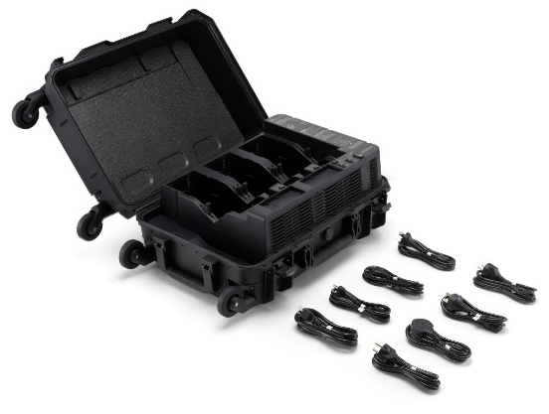
Ports and interfaces: USB-C × 2 / USB-A × 1 / Slot WB37 × 4 / Slot TB65 × 8.
Operating temperature: -20...40 °C.
Input voltage (min) 100 V.
The input voltage (max) is 240.
Weight 9.03 kg.
Dimensions (W×H×D) 58.0×35.8×25.4 cm.

6) Digital Lidar Video Camera DJI Zenmuse L2
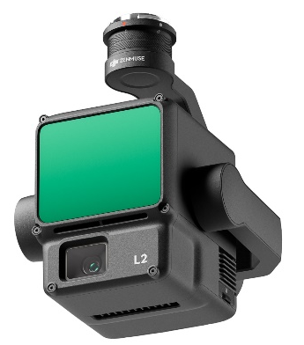
Video Resolution: 4K: 3840×2160@30fps / FHD: 1920×1080 @30fps / MP4 (MPEG-4 AVC/H.264) / Photo Size 5280×3956 (4:3) / JPEG/DNG (RAW).
Lens: Equivalent Format: 24 mm / Aperture range: f/2.8 - f/11
Lens viewing angle: 84 degrees.
Ports and interfaces: USB-C / microSD.
Operating temperature: -20...50 °C.
Dimensions (W×H×D): 15.5×12.8×17.6 cm.
Weight 905 g.

7) Laptop Field Protected 15.6" FHD IPS Intel Ci5-1235U 4.4GHz, 8GB RAM, 256Gb PCIe SSD,Wi-Fi 6E, BT 5.3, VGA, HDMI, RJ-45, COM, 2xUSB 3.2, USB type C, T battery 7600mAh, Win 11 Pro
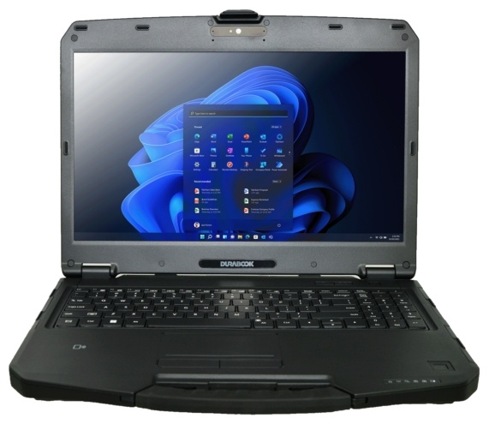
Case type: Protected.
Screen diagonal: 15.6
Screen resolution: FHD 1920x1080 (16:9).
Matrix manufacturing technology: IPS.
Processor manufacturer: Intel.
Processor series: Core i5.
Processor model: 1235U.
Processor frequency: 3.3 MHz.
Processor frequency in Turbo Boost mode: 4.4
Number of cores: 10.
Number of threads: 12.
RAM capacity: 8 GB.
Total number of RAM slots: 2 slots.
Type of installed drive: SSD.
SSD capacity: 256 GB.
Video card type: Built-in.
Battery capacity: 7600.
Operating system: Windows 11 Pro.
Body material: Plastic.

