Technical characteristics of the purchased goods

1) ASUS ExpertBook B9 B9403CVAR laptop, OLED (90NX05W1-M01KP0):

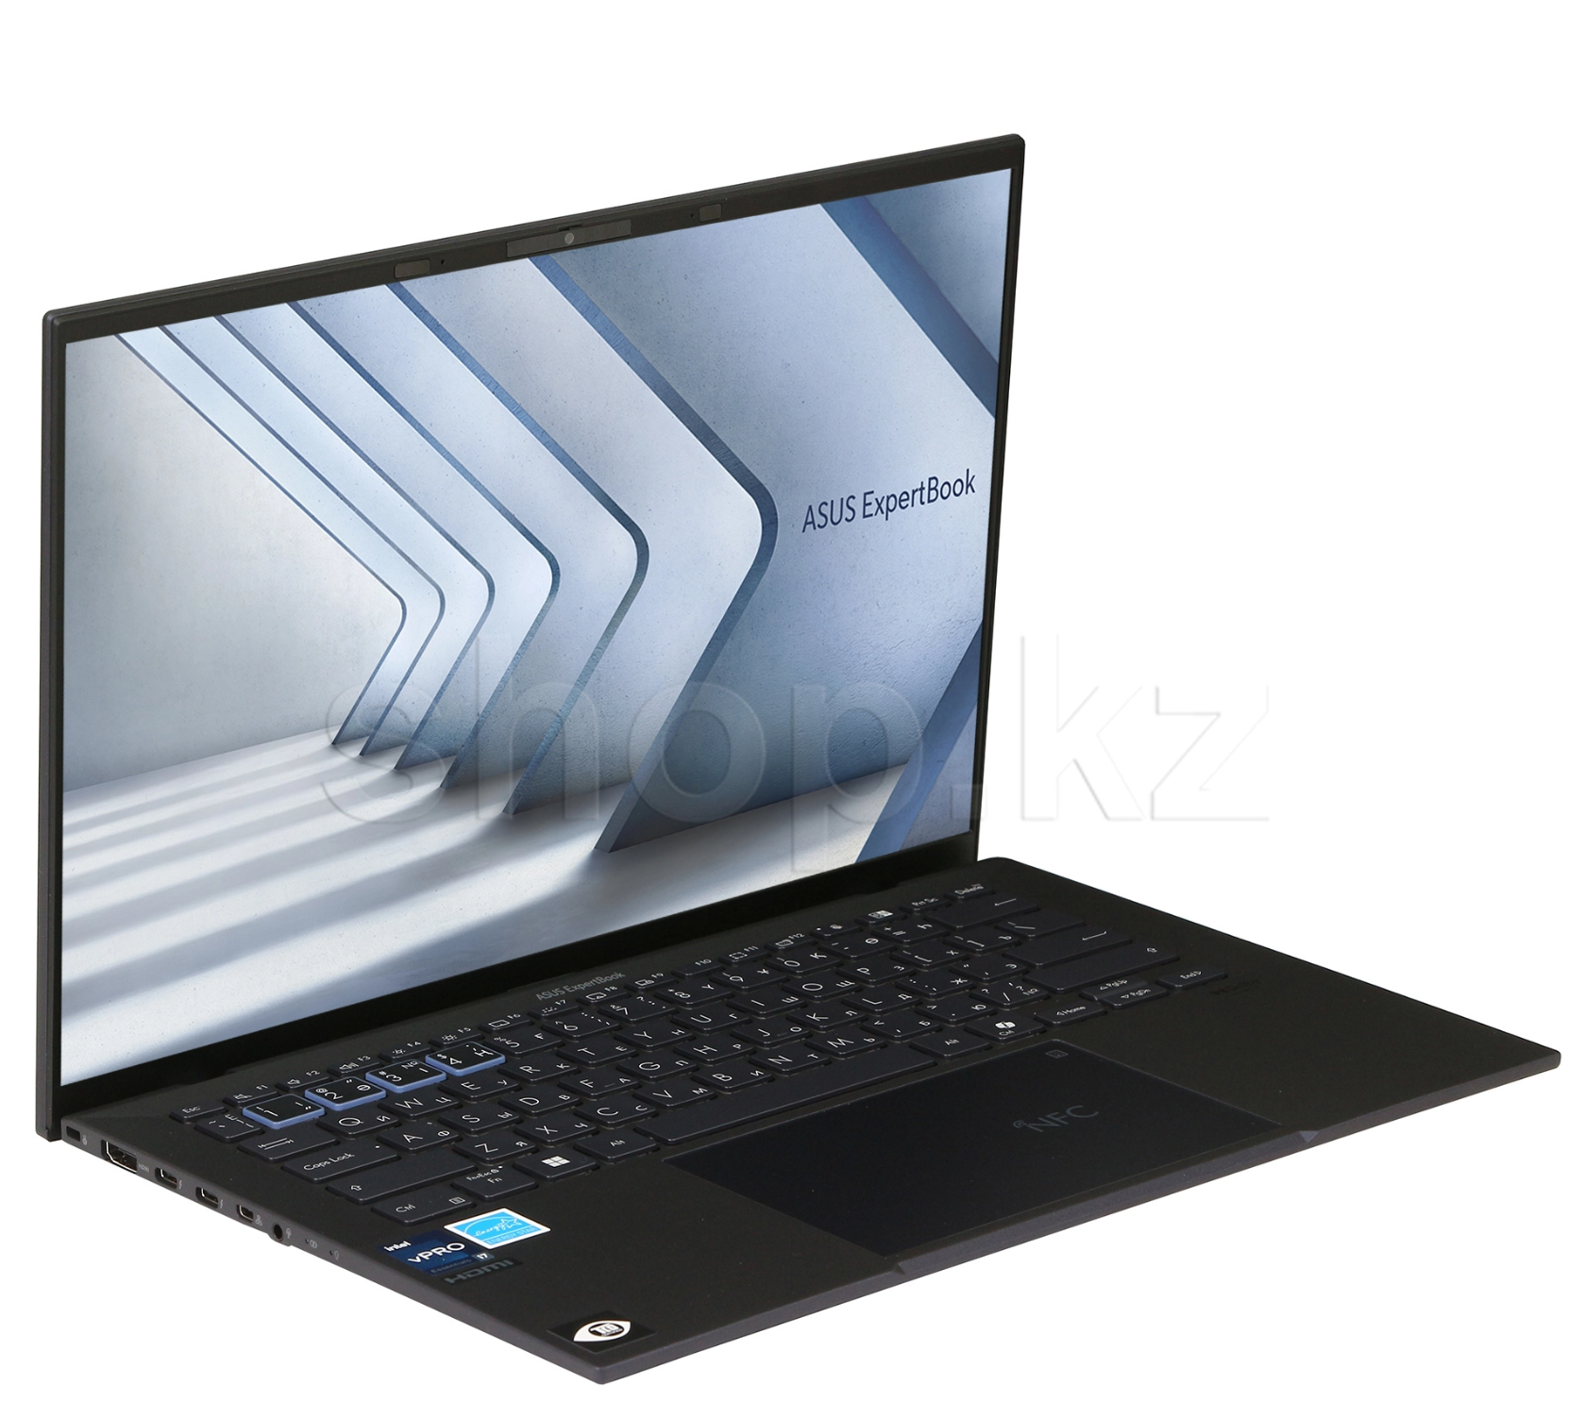

Product UID - 90NX05W1-M01KP0
Manufacturer - ASUS
Model - ExpertBook B9 B9403CVAR-KM0838X
Processor - Intel Core 7
Processor model - 150U
Processor frequency, GHz - 1.8
Maximum processor frequency, GHz - 5.4
Number of cores - 10
L3 cache - 12 MB
Video card type - Graphics integrated into the processor
Integrated graphics in the processor - Intel Graphics
RAM type - LPDDR5X
The amount of RAM, GB - 32
RAM configuration - 32 GB (soldered on the board)
The maximum amount of RAM is 32 GB.
Solid-state drive - 1 TB SSD
M.2 SSD slot - with PCIe interface
Features - OLED display
Screen diagonal, inches - 14
The screen resolution is 2880 x 1800
Screen brightness, cd/m2 - 400
The screen surface is Glossy
Battery Type - Lithium-ion (Li-Ion), Non-removable
Battery capacity - 63 Wh
Power adapter - 20 V, 65 W
Connectors - HDMI, Thunderbolt 4x2, Microphone input/Headphone output (combined), Micro HDMI
Number of USB 3.1 Gen 2 / USB 3.2 Gen 2 - 1 connectors
USB Type-C Power Delivery
Communication tools - Wi-Fi (802.11ax), Bluetooth, NFC
Bluetooth version - 5.3
Multimedia - Webcam, Speakers, Microphone
Finishing materials - Plastic, Metal
Security - Fingerprint Scanner, Kensington Nano Lock Slot
Webcam Features - Infrared Camera, Physical Shutter on Camera, 1080p FHD Resolution, Camera for Windows Hello function
Keyboard Features - Backlit keys
Case Features - Ultralight magnesium-lithium alloy case

2) Operating system Microsoft Windows 11 Professional, 64-bit, USB:

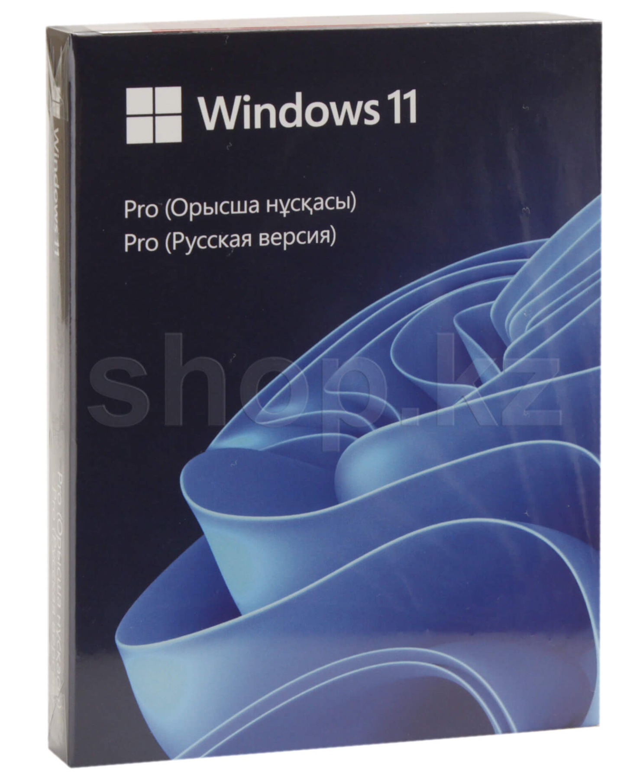
Product UID - HAV-00160
Manufacturer – Microsoft
The system's bit depth is 64-bit
Recommended system requirements:
Processor: at least 1 GHz or SoC, at least 2 cores
RAM: 4 GB
Hard disk space: 64 GB
System firmware: UEFI, with secure boot support
TPM version 2.0
Graphics card: DirectX version 12 or higher with WDDM 2.0 driver
Screen resolution: 720p with a diagonal of more than 9 inches, 8 bits per color channel
Internet access
Microsoft Account
Interface language - Russian
Packaging - BOX
Additionally:
Interface: USB 3.0
Microsoft Edge is a fast, secure browser
Microsoft Store - purchase and download of apps, games, movies, and desktop themes
Snap Layouts - grouping open windows into a perfect grid
Microsoft Teams - connect with any user directly from their desktop
Touch, handwriting, and voice input
Widgets
Device data encryption using BitLocker
Firewall and network protection
Parental control and protection
Windows Hello
Windows Information Protection (WIP) - protects enterprise applications and data from unintended data leakage

3) 2 TB External SSD, Kingston XS1000, Black:

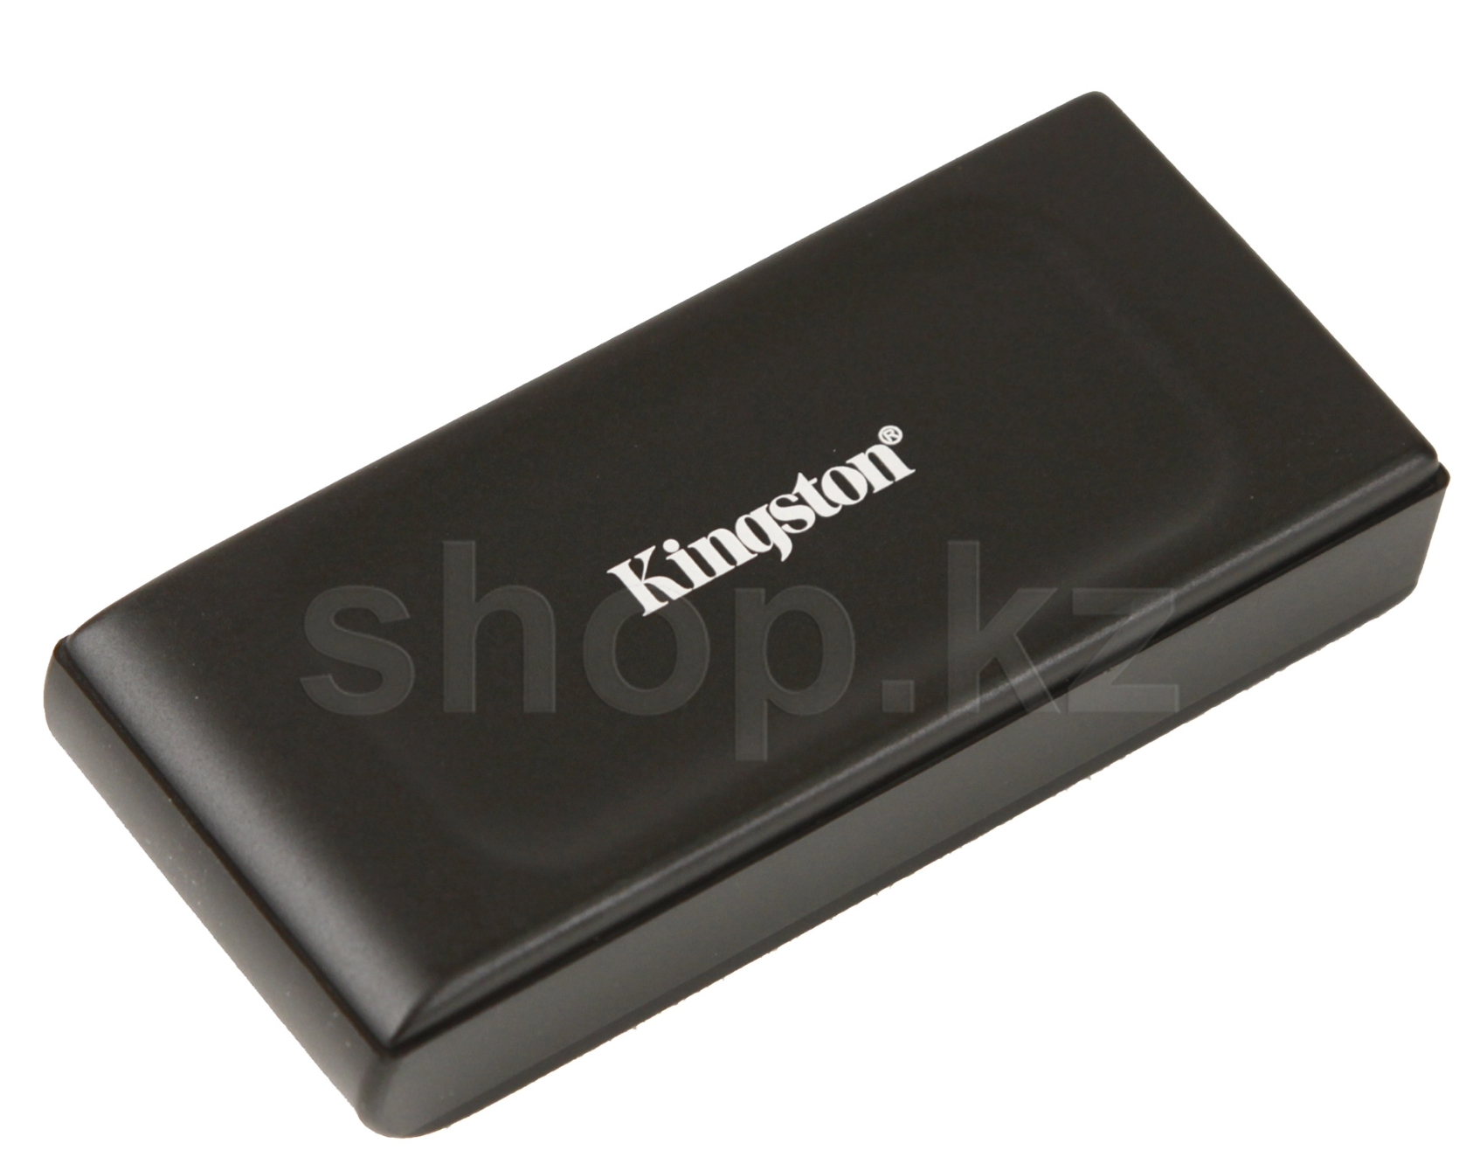

Product UID - SXS1000/2000G
Manufacturer - Kingston
Model - XS1000
Hardware Type - USB SSD
Memory capacity, GB - 2000
Read speed, up to - 1050 MB/s
Write speed, up to - 1000 MB/s
Interface Type - USB 3.2 Gen 2

4) Logitech Lift Vertical Ergonomic Mouse, Graphite, Pale Grey, USB:

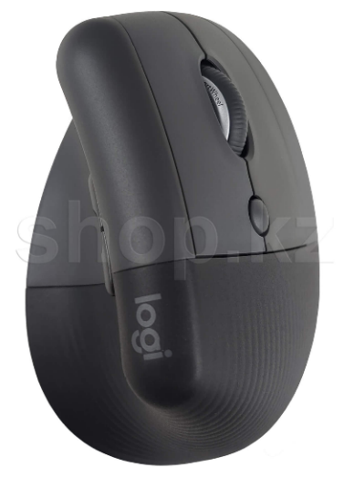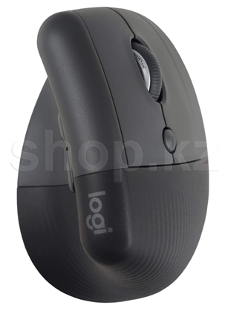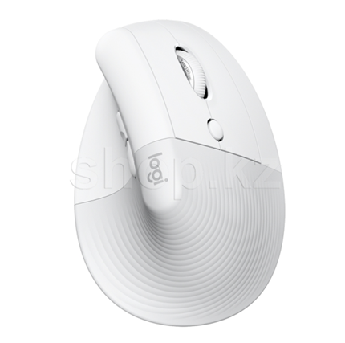

The product UID is 910-006475
Manufacturer - Logitech
Model - Lift
Type - Vertical Mouse
The case materials are Recycled plastic
Color – Gray, Light gray
Sensor type - Optical
Maximum resolution, dpi - 4000
Resolution modes, dpi - 400, 1000, 4000
Connection type - Wireless
Connection interface - USB, Bluetooth
Control buttons - "Click" - left and right buttons, "Forward" and "Backward"
Middle button, Scroll wheel with center button function
The number of buttons, including the button wheel, is 6
Power supply - 1 x AA, included
Range of action, m - 10
Compatible with - macOS 10.15, Windows 10, 11 and later

5) Network filter Defender DFS-135, 5 sockets, 5m, White:

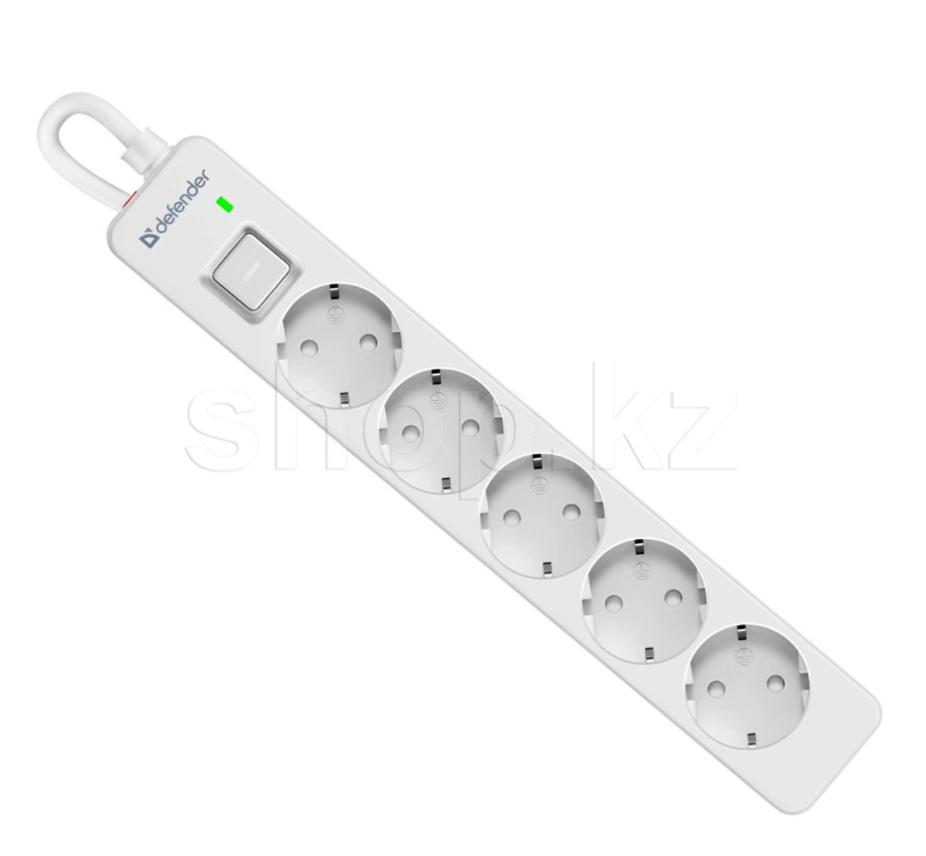
The product's UID is 99432
Manufacturer - Defender
Model - DFS-135
Device Type - Network Filter
Number of outlet outlets - 5
Cord length, m - 5
The type of sockets is a European standard with grounding
The maximum load current is 16 A
The nominal input voltage is 230 V
The frequency of alternating current is 50 Hz
Total load capacity, W - 3680
Protection - Against overload, Short circuit, And pulse interference
Indication - An indicator of network connection
Features - Wall mounting, Fireproof material
The maximum dissipated energy is 380 joules.

6) Network filter Defender DFS-143, 4 sockets, 3m, 1xUSB Type-C, 2xUSB, White:
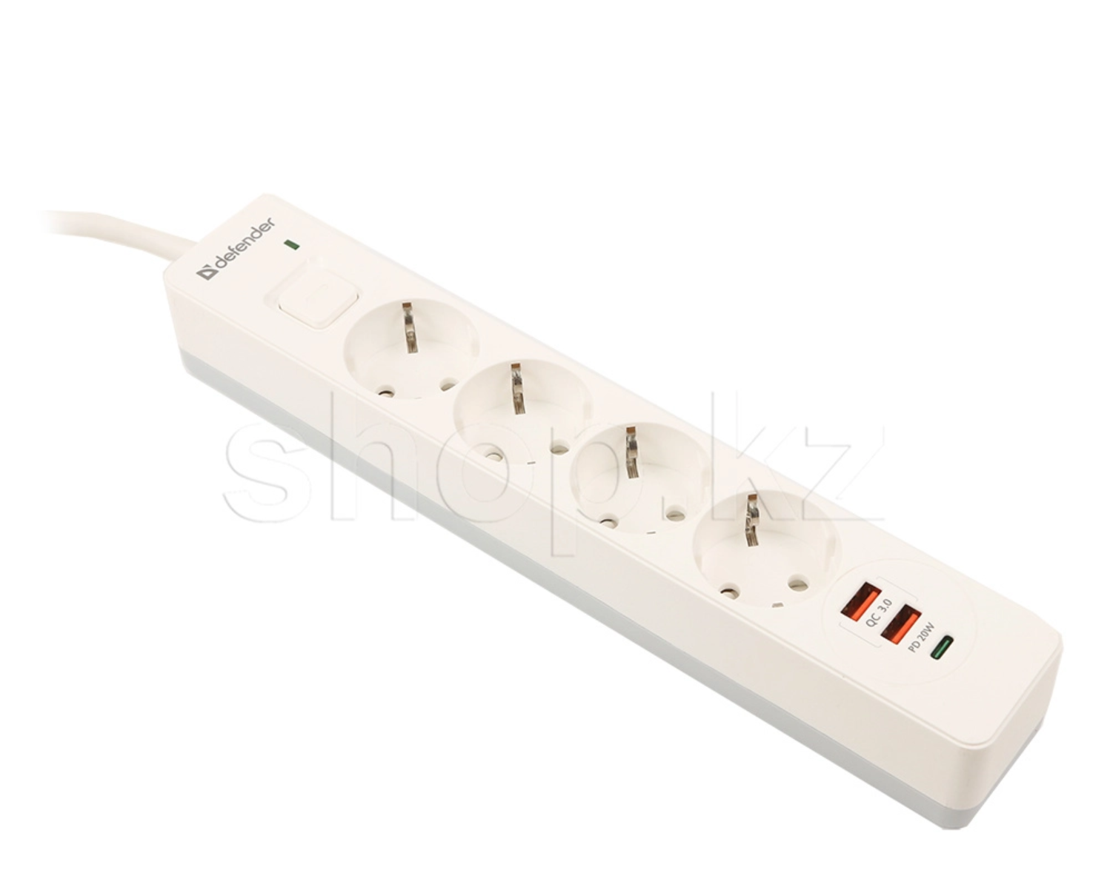
The product's UID is 99434
Manufacturer - Defender
Model - DFS-143
Device Type - Network Filter
Number of outlet outlets - 4
Cord length, m - 3
The type of sockets is a European standard with grounding
Number of USB connectors - 2
Maximum current of the USB port, A - 2.1
The maximum load current is 16 A
The nominal input voltage is 230 V
The frequency of alternating current is 50 Hz
Total load capacity, W - 3680
Protection - Against overload, Short circuit
Indication - An indicator of network connection
Features - Wall mounting, Fireproof material
The maximum dissipated energy is 380 joules.
Additionally, there is current protection of USB ports, an automatic fuse built into the switch.

7) USB HUB 4-port USB 3.2 Orico M3U4-G2-05-SV-BP, Silver:

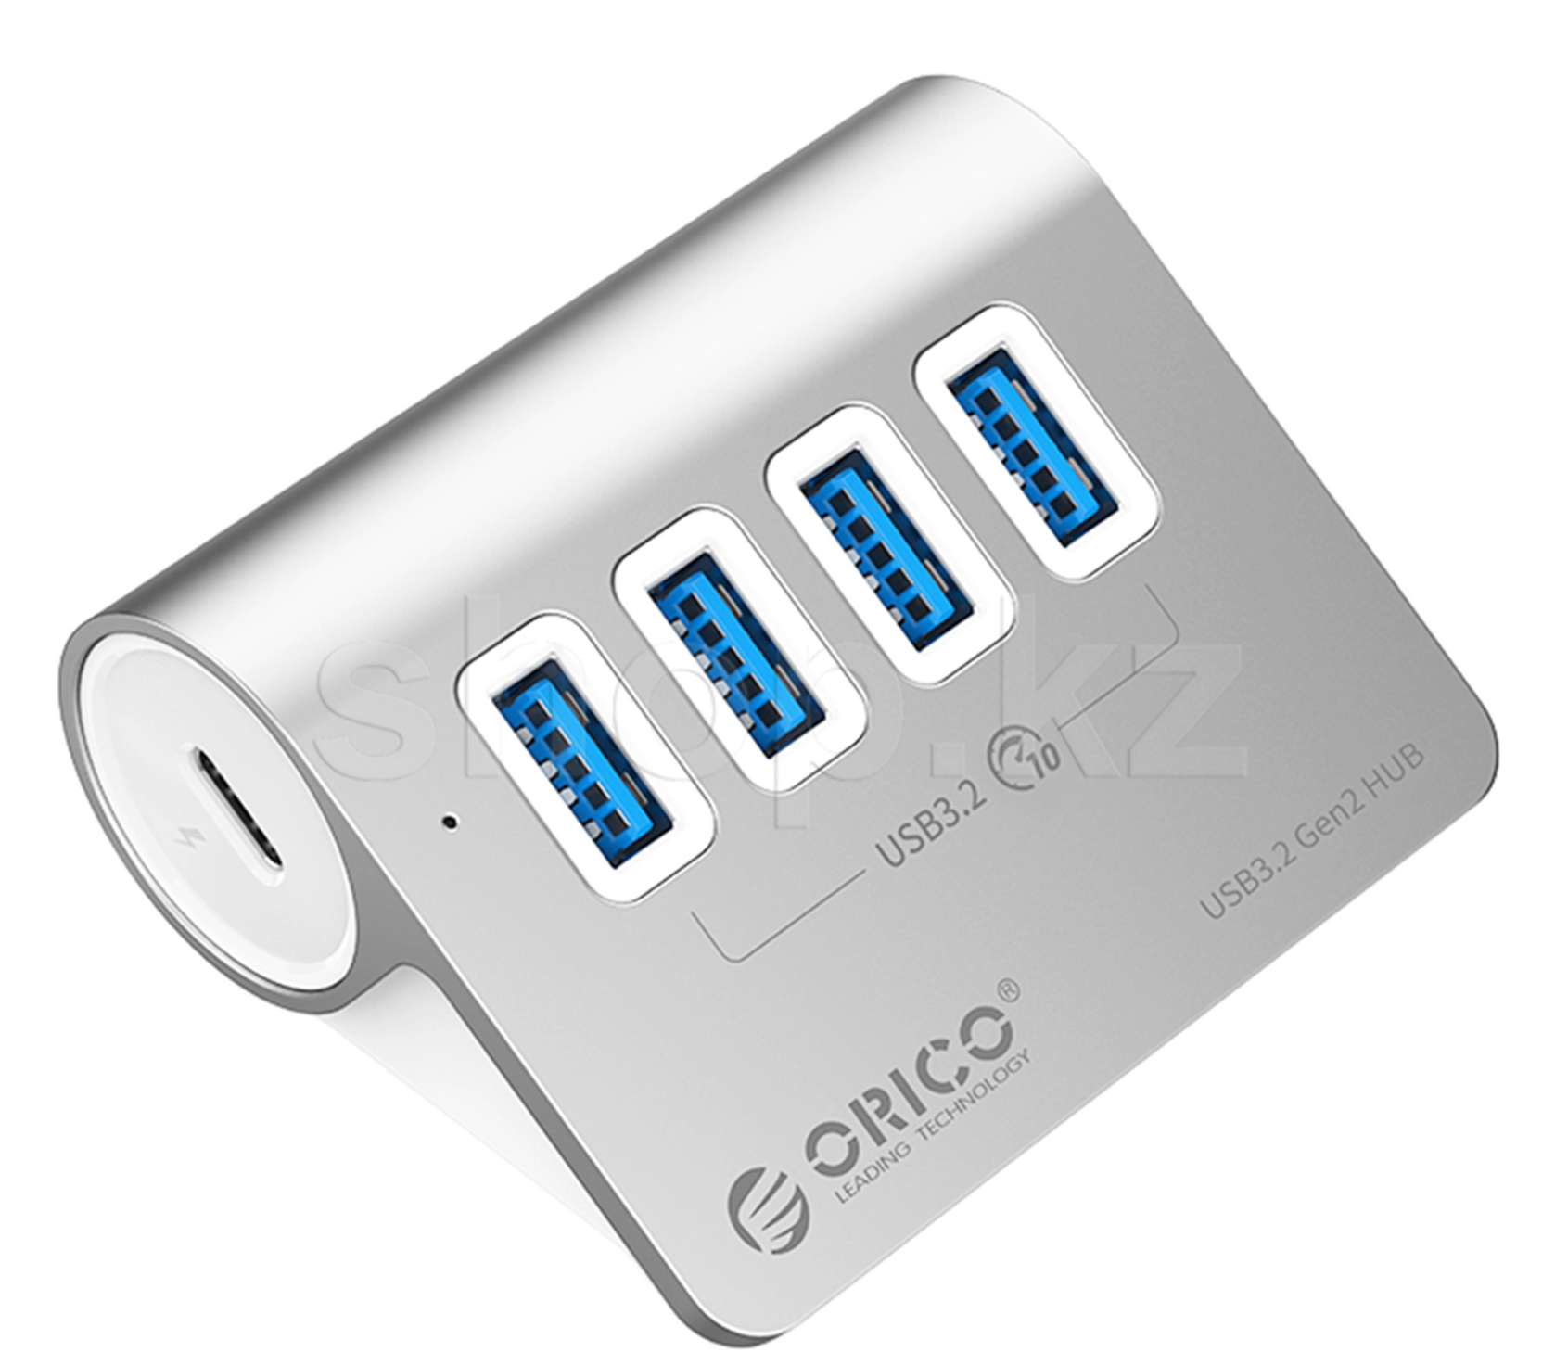
Product UID - M3U4-G2-05-SV-BP
Manufacturer - Orico
Model - M3U4-G2
Hardware Type - USB hub
Interface - USB
The transfer rate of the interface is 10 Gbit/s.
Compatibility - Windows XP, Vista, 7, 8, 8.1, 10, Mac OS and Linux
USB: v3.2, 3.0, 2.0, 1.1, 1.0
Description - USB-C 3.2 Gen2 Hub Connection Port, USB 3.2 Gen2 Type-A x 4 ports, Housing material: Aluminum, USB-C - USB-A cable length 0.5 m
Powered by USB port
Cable length, m - 0.5

